#ScrapTheYard Mass email campaign
This is a mass email campaign with targeted messages for the following Councillors:
- everyone on Lambeth’s Planning Committee – including the substitutes
- our nine local Councillors (Thurlow Park, Knights Hill, Gipsy Hill wards)
- the two new job share Cabinet Members for Sustainable Transport, Environment and Clean Air (new leader Cllr Claire Hollands previous job).

We have divided their emails into three roughly equal groups (9,9,8) and have a different email to send to each of them:
Group One – 9 emails: Health and Climate Facts – Monday 21 June
Group Two – 9 emails: aftermath of Lambeth’s Clean Air Day – Wednesday 23 June
Group Three – 8 emails: Effects on Schools and Homes – Friday 25 June

It would be terrific if you would take part, and if you can’t send todays emails today, then please do so whenever you can.

Group Two, target day Wednesday 23 June (but please send whenever you can)
Please can you send 9 individual emails to the following Cllrs with the subject line and message below:

Lambeth Council - Planning Committee June 2021
Position | Name | Ward | Political party | Email
Vice Chair | Councillor Scarlett O'Hara | Coldharbour | Labour | sohara@lambeth.gov.uk
 | Councillor Mohammed Seedat | Streatham Wells | Labour and Co-operative Party | mseedat@lambeth.gov.uk
Substitute | Councillor Rezina Chowdhury | Streatham Hill | Labour | rchowdhury@lambeth.gov.uk
Substitute | Councillor Paul Gadsby | Vassall | Labour | pgadsby@lambeth.gov.uk
Substitute | Councillor Nigel Haselden | Clapham Town | Labour and Co-operative Party | nhaselden@lambeth.gov.uk
Other key Councillor contacts
Cabinet Member for Sustainable Transport, Environment and Clean Air (job-share) | Councillor Dr. Mahamed Hashi | Stockwell | Labour | mhashi@lambeth.gov.uk
Local Councillors
 | Councillor Fred Cowell | Thurlow Park | Labour and Co-operative Party | fcowell@lambeth.gov.uk
 | Councillor Jane Pickard | Knights Hill | Labour | jpickard@lambeth.gov.uk
 | Councillor Matthew Bennett | Gipsy Hill | Labour and Co-operative Party | mpbennett@lambeth.gov.uk

Subject line: #ScrapTheYard - Lambeth's support for #CleanAirDay

Dear Councillor XXX

You are probably aware of the #ScrapTheYard campaign against planning application 20/01066/EIAFUL. Submitted on behalf of Southwark Metals it’s for a major scrap yard at Windsor Grove, West Norwood.

This application has provoked more than 2400 Lambeth citizens to make their written objections to Lambeth, and more than 5000 have signed a petition against it.

In Cllr Holland’s acceptance speech as leader she declared Lambeth to lead the London Boroughs on “Tackling Climate Change”.

Lambeth showed its passion to “clean-up our air” and “tackle climate change” with a webinar for Clean Air Day built around the film Diesel: The Industry’s Smokescreen.

Cllr Danny Adilypour, Lambeth Cabinet Member for Sustainable Transport, Environment and Clean Air, said:
"It was great to chair our Clean Air Day screening of the Diesel documentary. The film highlighted the pollution caused by diesel vehicle emissions and the discussion afterwards highlighted how important the issue of air pollution is to many of our residents.

“In Lambeth we are clear that improving local air quality is one of our top political priorities and we are committed to working with residents and local businesses to clean up our air, so that Lambeth continues to be a place that people want to live, work and invest in."

It quoted research reporting 4000 diesel related premature deaths in Europe.

Southwark Metals planning application, currently under consideration by Lambeth, would increase traffic by a massive quarter-million vehicle miles in the borough each year. A considerable portion would be by diesel HGVs.

The plan by Southwark Metals to move its operation from Lewisham to West Norwood would bring laden traffic down the length of Lambeth to discharge scrap at Windsor Grove and then return empty.

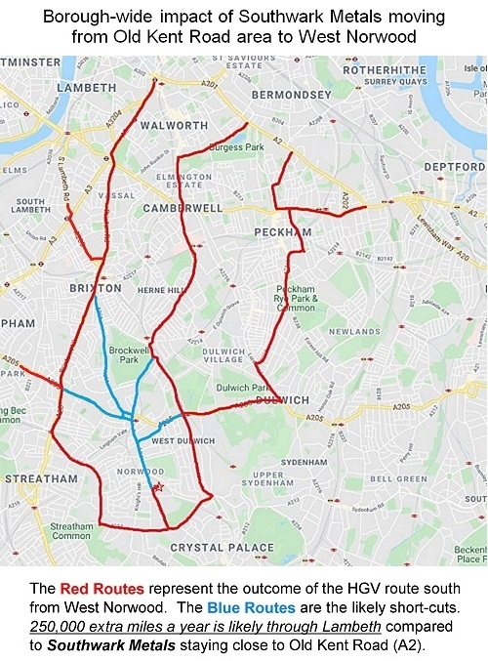

Please, engage with Lambeth Climate Change Assembly. Please advise Council Leader Claire Holland, cabinet members and planning officers that I have objected to this application. I believe that refusal is the only conscionable option.

Relevant NPPF, London and Lambeth policies are in place and must have proper and full regard paid to them.

Yours sincerely - Your name

