#ScrapTheYard Mass email campaign
This is a mass email campaign with targeted messages for the following Councillors:
- everyone on Lambeth’s Planning Committee – including the substitutes
- our nine local Councillors (Thurlow Park, Knights Hill, Gipsy Hill wards)
- the two new job share Cabinet Members for Sustainable Transport, Environment and Clean Air (new leader Cllr Claire Hollands previous job).

We have divided their emails into three roughly equal groups (9,9,8) and have a different email to send to each of them:
Group One – 9 emails: Health and Climate Facts – Monday 21 June
Group Two – 9 emails: aftermath of Lambeth’s Clean Air Day – Wednesday 23 June
Group Three – 8 emails: Effects on Schools and Homes – Friday 25 June

It would be terrific if you would take part, and if you can’t send todays emails today, then please do so whenever you can.

Group One, target day Monday 21 June (but please send whenever you can)
Please can you send 9 individual emails to the following Cllrs with the subject line and message below:

Lambeth Council - Planning Committee |  | Ward | Political party | Email
Chair | Councillor Joanne Simpson | Princes | Labour | jsimpson2@lambeth.gov.uk
 | Councillor Malcolm Clark | Streatham Wells | Labour and Co-operative | mclark@lambeth.gov.uk
 | Councillor Jessica Leigh | Ferndale | Labour and Co-operative | jleigh@lambeth.gov.uk
Substitute | Councillor Liz Atkins | Streatham Hill | Labour | latkins@lambeth.gov.uk
Substitute | Councillor Jennifer Brathwaite | Gipsy Hill | Labour and Co-operative Party | jbrathwaite@lambeth.gov.uk
Substitute | Councillor Marcia Cameron | Tulse Hill | Labour | mcameron@lambeth.gov.uk
Other key Councillor contacts
Environment | Councillor Danial Adilypour | Streatham South | Labour | dadilypour@lambeth.gov.uk
Local Councillors
 | Councillor Anna Birley | Thurlow Park | Labour and Co-operative Party | abirley@lambeth.gov.uk
 | Councillor Jackie Meldrum | Knights Hill | Labour | jmeldrum@lambeth.gov.uk

Subject line: #ScrapTheYard 1 - Quick Health and Climate Facts

Dear Councillor XXX

You are probably aware of the #ScrapTheYard campaign against planning application 20/01066/EIAFUL. Submitted on behalf of Southwark Metals it’s for a major scrap yard at Windsor Grove, West Norwood.

Perhaps the campaign can provide you with some key facts as to why this policy busting application has provoked more than 2400 Lambeth citizens to make their written objections to Lambeth, and more than 5000 have signed a petition against it.

In Cllr Holland’s acceptance speech as leader she declared Lambeth to lead London Boroughs on “Tackling Climate Change”.

The indications are that planning officers are to recommend approval. I have objected to this application and I ask you to make my feelings known to the planning officers, to Council Leader Claire Holland, and the entire Cabinet.

The application contradicts Cllr Holland’s stated ambition and the campaign believes it will damage public health.

#ScrapTheYard
250,000 EXTRA vehicle miles each year down the length of Lambeth

#ScrapTheYard
25,000 tonnes of scrap metal each year to be ‘imported’ from Lewisham area for no reason

#ScrapTheYard
Brixton and Streatham Air Quality Focus Areas to be violated by unnecessary HGVs

#ScrapTheYard
Giant Scrap Yard next to homes and two schools would screw ALL of Lambeth with traffic and pollution

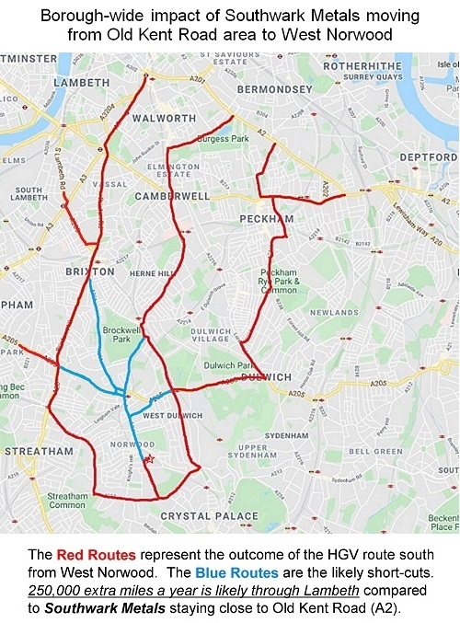

Lambeth endorses London Plan Policy SI1A. This starts “Plans must deliver further improvements to air quality and should not reduce air quality benefits that result from the Mayor’s or boroughs’ activities to improve air quality”

Yours sincerely

Your name

