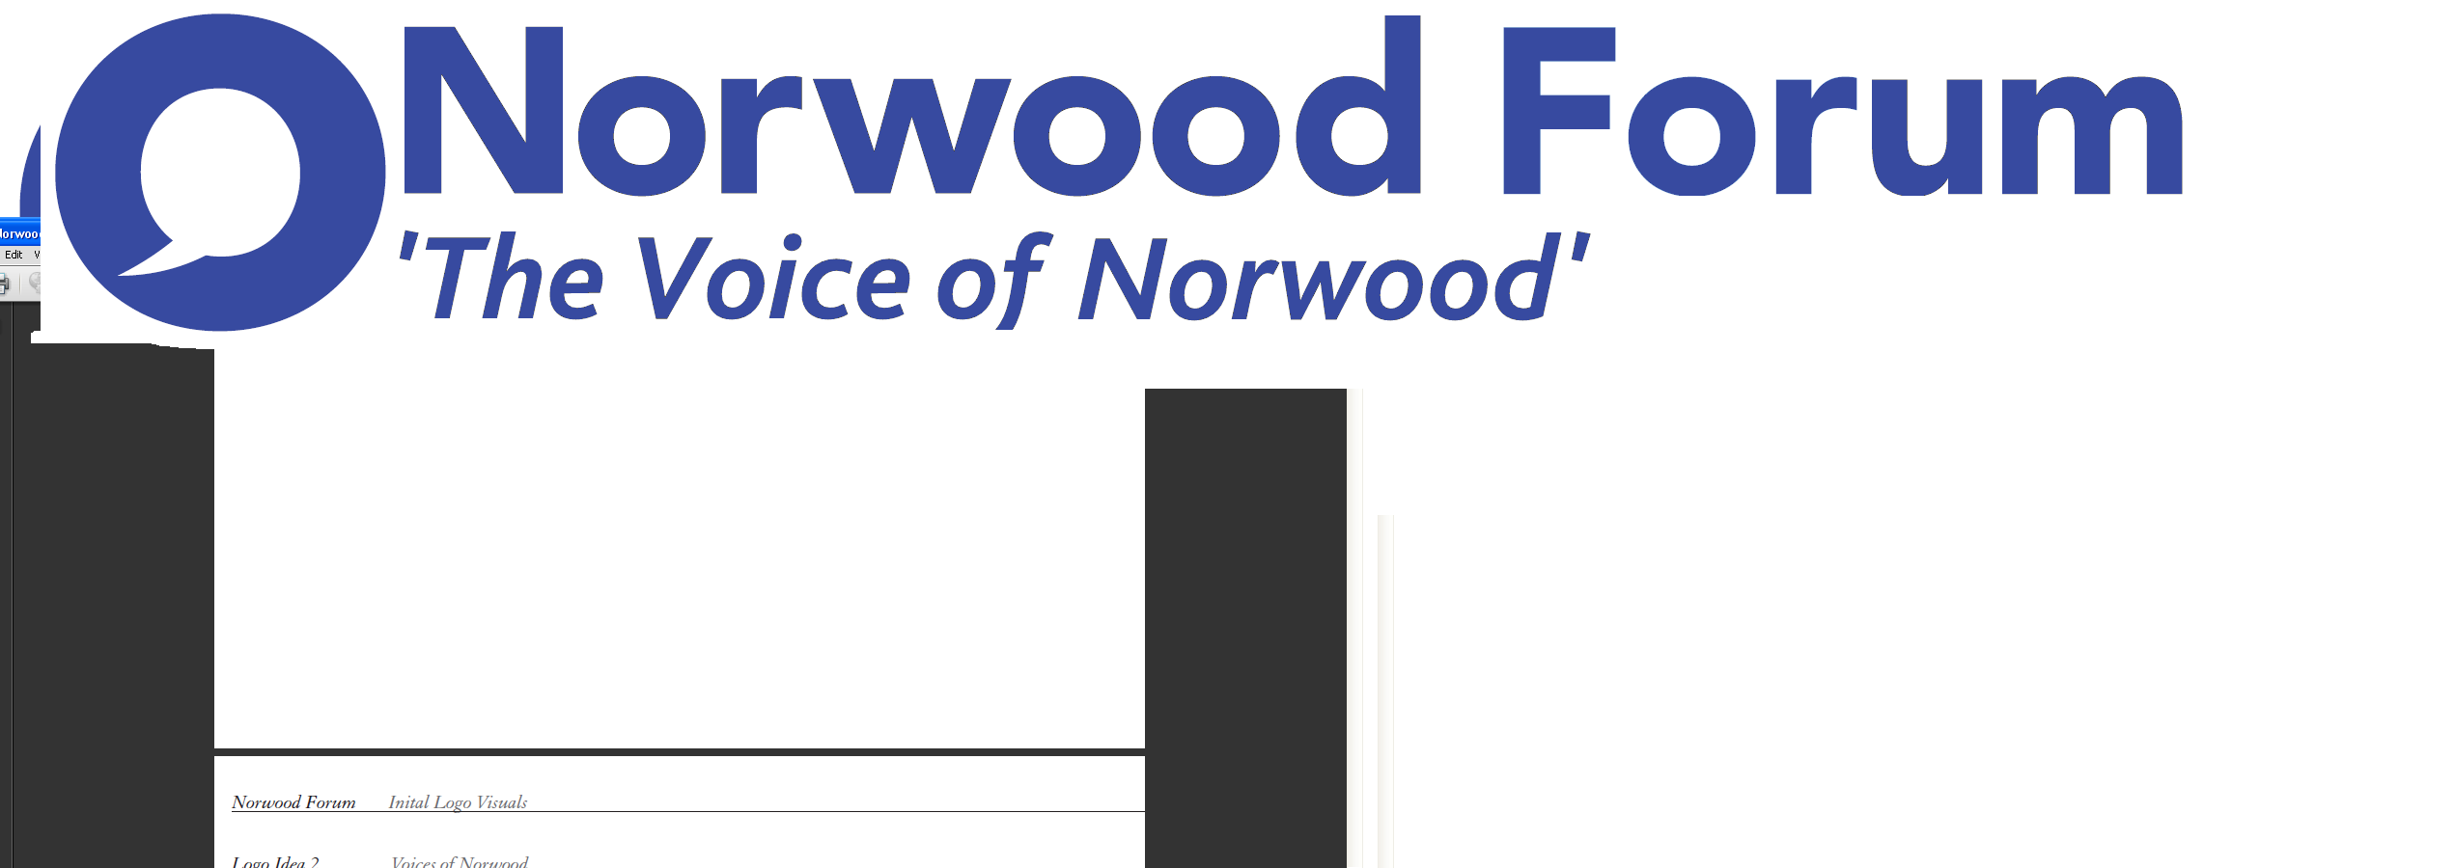

info@norwoodforum.org

**Norwood Forum Committee**

**Monday 9 January 2017 at 7:30pm**

**The Old Library 14-16 Knights Hill SE27 0HY**

**Minutes**

**Present:** Su McLaughlin (SMcL), **Gloria Orosungunleka (GO),** Noshir Patel (NP) (Chair), Sunil de Sayrah (SdS) (Treasurer) and Jan Ware (JW) (Secretary)

**Apologies:** Sharon Fuller (SF); Councillor Fred Cowell and Sarah Coyte (SC) (Lambeth Council)

**Also present:** Tim Stephens (TS) (Administrator)

1. **Declarations of interest**

JW would not take part in any decisions on letting rooms at The Old Library for Norwood Forum business.

1. **Minutes of last meeting (6 December 2016) and matters arising**

The minutes of the meeting held on 6 December 2016 were approved. The following matters arising were discussed:

Friends of Norwood Park

SdS would again invite a representative the Friends to attend.

Streetworks newsletter

A newsletter had been sent out earlier that week.

The continuing poor public realm at Waylett Place was discussed. It was agreed that further council intervention – e.g. freshview, involvement of the new residents of “The Loft”, plus some greening initiatives by the community were urgently required if the car park was to be seen as a credible alternative car parking area for those to be removed as a result of the Norwood Road works. NP would raise at that Friday’s Streetworks Project Board.

Norwood News

St Lukes Church clock story would now need amendment to publicise the offer from Elemento to pay the outstanding balance on the crowdfunding campaign. The Committee noted the action being taken to make it plain that this donation was between the Church authorities and Elemento.

Possible publication in B&W hard copy format to be discussed at next meeting - in light of quote from Rathbone which JW would now obtain.

Tuition session: at Tim’s place on 24 January at 11am.

West Norwood Library/Cinema progress to be one story for the following newsletter; JW had photos and NP to seek Councillors assistance for site visit and update on ongoing works.

Training opportunities from the Forum: SdS would discuss with JW.

The Tritton Road Pocket Garden: JW had this in hand, along with another item.

Opportunity to tender for the new website

Colin Fenn was not able to assist.

Public meeting

Discuss at next meeting, in light of the work required to support the forthcoming NPA public meeting (24 January 2017) and Streetworks public meeting (now confirmed for 6 February 2017).

Social media

As the Norwood Forum facebook page was not stand alone, it would not be possible to link mailchimp to that page. Paid advertisements should be considered for future events. As Norwood News would be published every other week on the Facebook page, every effort should be made to at least publish one story on the other weeks.

1. **Norwood Planning Assembly**

Proposed constitution: concerns on the content, and in particular the membership arrangements and appointment of Executive members, were discussed. The NAG steering group was due to meet on 17 January, and all Norwood Forum Committee members would be invited to attend so that the constitution could be finalised and published for presentation to the public meeting on 24 January.

1. **Forum communications**

Norwood News and social media: see above.

Website: TS to proceed to seek quotes from local contacts on a new website. Use Tulse Hill Forum and friends of Brockwell Park as examples. Possible platform: wordpress; possible email: gmail (retaining [info@norwoodforum.org](mailto:info@norwoodforum.org)); automatic feed for Streetworks. Training to be included in package. JW to be the responsible officer.

1. **Streetworks**

The date for the forthcoming important public meeting (where the future operation of the project would be discussed) was now confirmed as Monday 6 February 2017. All were urged to attend.

Noted that the forthcoming Steering Group meeting would be the opportunity to take decisions on spend on admin. and outreach/comms. for the remainder of the life of the project given the limited and diminishing resources available.

1. **Chair’s report**

Knollys Road development public meeting was imminent and should be the subject of a news item in the next newsletter.

1. **Treasurer’s report**

Nothing further discussed.

1. **Any other business**

Hungry Hippo café Norwood Park proposed rent rise: NP to make written representations and raise issue at Parks Forum to support existing arrangements for café.

Gipsy Hill Federation: agreed that the Committee would favour the planned temporary secondary school being located at the KIBA and not Glenbrook Primary School in Clapham in order to protect the interests of local children and bring a long blighted empty site back into use.

Station to Station meeting (10 January 2017) GO would attend with NP and this reported in the next newsletter.

Cycle of meetings: the Committee agreed to meet on the second Wednesday at 7pm and usually away from the Old Library, subject to the day of the week changing if another day would enable Sharon Fuller to better attend meetings. Subject to this, the next meeting would be held at theElmworth Grove Community Hall (Elmworth Grove, off Rosendale Road, SE21 8RA) on Wednesday 8 February 2017 at 7pm – JW to book.

The meeting ended at 9:40pm.

Chair

Norwood Forum

Wednesday 8 February 2017

|  |  |  |
| --- | --- | --- |
| **Action Points {xx.xx.xx} dates = meeting when discussed)** | **Who** | **Completed?/**  **when to be discussed** |
| 1. Newsletter: print copies and Rathbone cost estimate | SdS & JW |  |
| 1. Website: revamp {30.06.16, 21.09.16, 09.11.16 & 09.01.17} | TS |  |
| 1. Website: wordpress training   {30.06.16, 21.09.16, 09.11.16 & 09.01.17} | TS |  |
| 1. Website: update current content {09.11.16} | JW |  |
| 1. West Norwood Cinema/Library: visit and update {07.12.16 & 09.01.17} | NP |  |
| 1. Tritton Road Pocket garden and People’s Fridge {07.12.16 & 09.01.17} | JW |  |
| 1. Norwood News: discuss at every meeting {09.11.16} | TS |  |
| 1. LFN funding approved: plan required activity (including training opportunities) {07.12.16 & 09.01.17} | SdS |  |
| 1. Public meeting – March 2017: format and arrangements {09.11.16, 07.12.16 & 09.01.17} | All |  |
| 1. Norwood Planning Assembly: constitution and prep. for public meeting (24.01.17) {09.01.17} | All |  |
| 1. Streetworks spend on admin. and outreach/comms. {09.01.17} | NP/JW/SdS. |  |