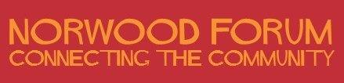

Annual General Meeting

Saturday 13 July 2019 (1:00pm – 2:30pm)

The Old Library, 14-16 Knight's Hill, West Norwood, SE27 0HY

AGENDA

- Welcome, Introductions and Apologies

- Minutes of the last AGM held on 16 June 2018 - and any matters arising

- A Year of Culture: presentation - Kim Hart (Committee member)

- Community Safety Partnership and violence reduction: presentation – Philip Virgo (Committee member)

- Community groups: presentations:
- Norwood Pensioners Group
- Rathbone Society Youth Project
- Southside Rehabilitation Association

- Chair’s report 2018-19 (to be tabled)

- Treasurer’s report 2018-19 (to be tabled)

- Election of Norwood Forum officers and committee members (details of nominations received will be tabled):
- Chair
- Vice-Chair
- Secretary
- Treasurer
- Committee member (without portfolio) – up to 11 members

_______________________

Contact: info@norwoodforum.org
c/o The Old Library, 14-16 Knights Hill, West Norwood, London, SE27 0HY

Noshir Patel
Chair
Norwood Forum
6 June 2019

