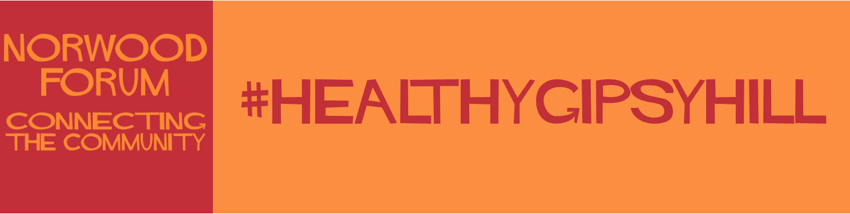

This is NOT the application form, but a copy for you to read all the questions in advance and help you draft your answers

#HealthyGipsyHill - Gipsy Hill Health & Wellbeing Small Grants Fund - phase one

This is a short application form to apply for a project grant from this new scheme which is being funded by Lambeth Council and managed by Norwood Forum. Your project must be designed to enhance the health and wellbeing of (primarily) the residents of Gipsy Hill and you will see the list of local priority groups later in this application. You do not need to be based in Gipsy Hill. The maximum you can apply for is £5,000, but if your project only requires £100 it will receive the same care and attention. There is an option to apply for two years of funding. The deadline to apply is 12 noon Wednesday 9 February 2022, and the decision of the adjudication panel will be final, and subject to funds being available. On receipt of your application you may be asked to provide further details. If you need help answering any of the questions, please contact: info@norwoodforum.org

Who are you?
Your name:

Name of your organisation (if any):

The contact email we should use:

Your address:

Website - if you have one - or your other main online platform:

Your project
Your project must be designed to enhance the health and wellbeing of (primarily) the residents of Gipsy Hill. We expect the project to have begun, or at least be in the planning stages, by 31 March 2022. Below are the priority groups. Applicants projects must be designed to reach at least one of these. You will need to explain which group/s your project is designed to reach, as well as how you intend to reach them.

What is your project called?

Please briefly describe your project and include how many people you expect to take part in 2022:

Which of these priority groups is your project designed to reach. Please tick all that apply:
• People from Black, Asian and multi-ethnic groups
• Parents and carers on low incomes (particularly lone parent families)
• Young families
• Unemployed
• People experiencing poor mental health
• Isolated men (mainly single isolated men)
• Older people
• LGBTQ+
• People with disabilities/and or suffering with poor health.

What health and wellbeing outcomes will your project deliver to the groups you have ticked above. How will you evidence this?

What venue or facility will you use to run your project? This must be in Gipsy Hill unless you need specialist facilities that are only available elsewhere. If elsewhere, please explain how you will ensure Gipsy Hill residents can take part easily.

Please briefly describe how you will ensure the people involved in your project are primarily residents of Gipsy Hill:

Your experience
Please briefly describe your experience and expertise that will enable you to successfully deliver this project:

Please provide contact details of one referee who can vouch for your work: Name, organisation and email:

Budget
This will be a two year scheme. The maximum you can apply for in 2022 is £5,000, but you can apply for funding for 2023 as well. This will be dependent on the evaluation of your 2022 project. If you only need £100 for one year that will receive the same care and attention.

2022: Please provide a short breakdown of your proposed budget including other sources of income (which must already be guaranteed if this project cannot run without that money). Also include any in-kind support. We may come back and ask for more details.

2023: If you wish to apply for a second year's funding, please provide an outline budget here. Final approval will be dependent on the evaluation of your 2022project. We may come back and ask for more details.

How will you manage and account for this funding?

Dates
We expect your project to have begun, or at least be in the planning stages, by 31 March 2022

When do you plan to run your project? Please include pre-planning as well as project dates and if it is a one off, or a series of activities:

Thank you
Two final tick boxes:
Evaluation.
If your application is successful, we will ask you to:
1. Include Norwood Forum and Lambeth logos in all your project literature on and off-line and use #healthygipsyhill.
2. Distribute and collect back a short evaluation form to all the people who take part in your project. Norwood Forum will provide this in paper and online formats.
3. Your own evaluation within 4 weeks of your project finishing which should include: a short narrative, anonymised data of your participants, your evidence of the health & wellbeing outcomes achieved, and a short financial report. Photos and videos would also be welcomed.
4. We may also ask the grant recipients to attend a Gipsy Hill Health & Wellbeing Hub meeting to present your report in person.
Please tick the box to confirm you understand and agree to this.

Safeguarding, Insurance, Access and Legal Responsibilities:
We expect you to fully understand your professional responsibilities relating to yourself, your team(if you have any colleagues involved in this project), those participating in your project (adults or children), and the facilities you will be using. This includes access, insurance, data protection, current DBS checks where necessary, and relevant Covid-19 legal requirements and best practice, plus any other issues that relate to your particular project.
Please tick the box to confirm you will fully comply with all relevant requirements.

If you have any questions please email:info@norwoodforum.org

